[www.](http://www.)christur.com = Apocatastasis = Apokatastasis = Biblical Universalism = Christian Universalism = The Restoration of All = The Victorious Gospel = Universal Reconciliation = Universal Restoration = Ultimate Reconciliation = Ultimate Restoration = UR = 100+ Websites

Found a UR website not on this list? Please email me the link so I can add it here.

Email: [song@jesus-saves-all.com](mailto:song@jesus-saves-all.com)

Click blue underlined link to go to page. “Ctrl” and “Mouse Wheel” to Zoom in and Zoom out.

Enter the site into Wayback Machine if it’s down: [http://web.archive.org](http://web.archive.org/)

Use this Website Copier for offline copy: <https://httrack.com>

Images appearing stretched/duplicates? Clear your entire browsing and download history, cookies, cache, form and search history, site settings and offline website data.

Text Only Version:

Site Created: May 23 2023. Site Updated: June 13 2023

All people have sin. Wages of sin is death. Jesus Christ is God, He has no sin, He died, He resurrected. You must have faith alone in Jesus Christ only to gain permanent life. Therefore, everyone will become believers in Jesus Christ and thus all people will go to Heaven.

<https://abetterfuturenow.com/what-does-aionios-aion-eternal-mean/>

<https://www.reddit.com/r/JesusSavesAll/>

<https://web.archive.org/web/20230630174746/https://www.reddit.com/r/JesusSavesAll/>

<https://www.slideshare.net/gospelconversations/universal-salvation-a-whistlestop-introduction-hope-and-hell-conference?from_action=save>

<https://reforminghell.com/>

<https://www.britannica.com/biography/Elhanan-Winchester>

<https://womenofchristianity.com/mothers/hannah-whitall-smith/>

<https://www.jstor.org/stable/j.ctt1cg4m9c>

<https://searchworks.stanford.edu/view/9252119>

<https://takethescroll.blogspot.com/>

<https://twosidedscroll.blogspot.com/>

<https://www.blogger.com/profile/01985906997791106346>

<https://frostsodalis.wordpress.com/>

<https://jmshistorycorner.wordpress.com/2022/09/19/all-will-be-saved/>

<https://www.firstthings.com/article/2015/05/traditio-deformis>

https://journal.radicalorthodoxy.org/index.php/ROTPP/article/view/135

<http://www.nmuc.org/OffCentr.htm>

<https://www.reddit.com/r/ChristianUniversalism/wiki/famousuniversalists/>

<https://www.christiancentury.org/article/critical-essay/final-judgment-really-final?fbclid=IwAR1QtWXKsUYqALmsgeMbLC4E88j_wJCZnGWYRBkOPlvjJvtvXxBM2RStOuM>

<https://podtail.com/en/podcast/the-zeitcast-with-jonathan-martin/that-all-shall-be-saved-with-david-bentley-hart/>

<https://player.fm/series/crackers-and-grape-juice-2456625/episode-225-david-bentley-hart-that-all-shall-be-saved-heaven-hell-and-universal-salvation>

<https://theopolisinstitute.com/leithart_post/good-god-a-response/>

<https://yalebooks.yale.edu/2019/11/13/the-etiquette-of-hell/?fbclid=IwAR0VbA2jtnTEhizb1w0CEWSlEzRfec6iVF6DFqKst4MDbkcd-3WFT5MdJ-A>

<https://newsworthywithnorsworthy.podbean.com/e/david-bentley-hart-that-all-shall-be-saved/>

<https://www.churchtimes.co.uk/articles/2019/20-december/faith/faith-features/time-s-up-for-torment>

<https://www.nytimes.com/2020/01/10/opinion/sunday/christianity-religion-hell-bible.html>

<https://publicorthodoxy.org/2020/04/24/what-is-a-truly-free-will/>

<https://thedeconstructionists.com/ep-108-dr-david-bentley-hart-all-that-shall-be-saved/>

<https://www.davidartman.net/podcast/ep-61-dr-david-bentley-hart-author-of-that-all-shall-be-saved-that-all-shall-be-saved-with-a-brief-appearance-from-his-dog-roland-2>

<https://www.scribd.com/document/195047624/A-Gift-Exceeding-Every-Debt>

<https://www.davidartman.net/podcast/ep-83-david-bentley-hart-his-contextual-reading-of-the-sermon-on-the-mount-and-how-infernalism-distorts-it>

<https://tgulcm.tripod.com/cu/>

<http://experimentaltheology.blogspot.com/>

<http://theologicalscribbles.blogspot.com/>

<http://www.christianuniversalism.net/>

<https://nyscu.org/>

<https://universalistfriends.org/>

<https://relentless-love.org/articles/>

<https://quaker.org/legacy/pamphlets/QUF.html>

<https://www.worldcat.org/search?q=au%3AQuaker+Universalist+Fellowship.&qt=hot_author>

<https://isni.oclc.org/xslt/DB=1.2//CMD?ACT=SRCH&IKT=8006&TRM=ISN%3A0000000103103943&TERMS_OF_USE_AGREED=Y&terms_of_use_agree=send&COOKIE=U51,KENDUSER,I28,B0028++++++,SY,NISNI,D1.2,E51de6cf6-1a,A,H1,,3-28,,30-41,,43-59,,65-70,,74-75,R50.72.191.184,FY>

<https://viaf.org/viaf/153938756/>

<https://www.firstuniversalist.net/>

<https://www.redhilluniversalist.org/>

<https://www.christtheliberator.org/>

<https://zootown.church/>

<http://lcuchurch.com/>

<https://catholicuniversalistchurch-apac.weebly.com/>

<https://www.quakercloud.org/cloud/quaker-meeting-melbourne/pages/quaker-universalist-fellowship>

<https://www.friendsjournal.org/are-quakers-christian-non-christian-or-both/>

<https://archives.tricolib.brynmawr.edu/resources/4110quun>

<https://quakeruniversalist.blogspot.com/>

<https://reformedcelticchurch.blogspot.com/>

<https://www.patreon.com/user?u=87483055>

<https://web.archive.org/web/20060814181042/http://www.nyscu.org/About_Us/>

<https://web.archive.org/web/20060821064143/http://www.universalisminpa.org/>

<https://web.archive.org/web/20060821012459/http://www.westarinstitute.org/>

<https://web.archive.org/web/20060713095204/http://www.adinballou.org/>

<https://web.archive.org/web/20061206124025/http://www.tcpc.org/template/index.cfm>

Christian Universalist Supporters

Elhanan Winchester

George de Benneville

Hannah Whitall Smith

Peter Sterry

*“1 Cor 15:22 …in the Christ all shall be made alive.” (YLT).*

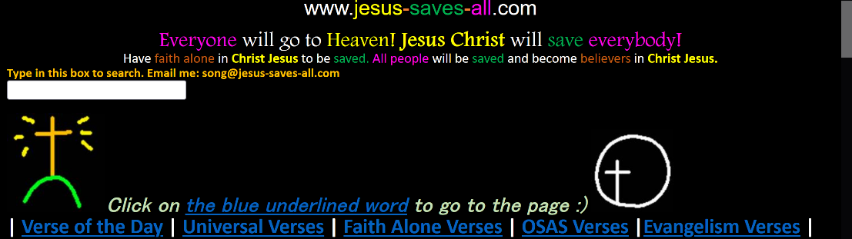

Jesus-Saves-All (My Website I Created)

<https://jesus-saves-all.com>

December 26, 2013 to May 16, 2023.

[http://web.archive.org/web/20230000000000*/https://jesus-saves-all.com](http://web.archive.org/web/20230000000000*/https://jesus-saves-all.com)

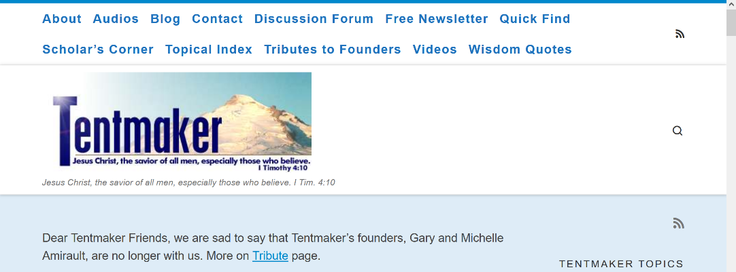

Tentmaker

<https://tentmaker.org/>

January 15, 1998 and May 15, 2023.

[http://web.archive.org/web/20230000000000*/https://tentmaker.org/](http://web.archive.org/web/20230000000000*/https://tentmaker.org/)



Christian Universalist Association

<https://christianuniversalist.org/>

March 28, 2002 to May 2, 2023.

[http://web.archive.org/web/20230000000000*/https://christianuniversalist.org/](http://web.archive.org/web/20230000000000*/https://christianuniversalist.org/)



Bible Hub

<https://biblehub.com/>

April 30, 2006 to May 14, 2023.

[http://web.archive.org/web/20230000000000*/https://biblehub.com/](http://web.archive.org/web/20230000000000*/https://biblehub.com/)

Ordered Alphabetically From Here:

____________



35th Center for Action and Contemplation

<https://cac.org/daily-meditations/universal-restoration-2018-09-13/>

April 12, 1997 to May 18, 2023.

[http://web.archive.org/web/20230000000000*/https://cac.org](http://web.archive.org/web/20230000000000*/https://cac.org)



600+ Bible Verses that Prove UR is True

<http://richardwaynegarganta.com/lovelacelist.htm>

April 14, 2008 to January 22, 2019.

[http://web.archive.org/web/20110715000000*/http://richardwaynegarganta.com/lovelacelist.htm](http://web.archive.org/web/20110715000000*/http://richardwaynegarganta.com/lovelacelist.htm)

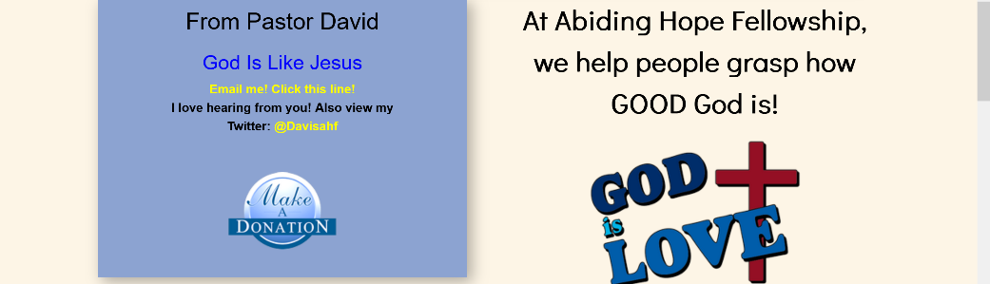

Abiding Hope Fellowship

[https://abidinghopefellowship.org](https://abidinghopefellowship.org/)

March 19, 2007 to April 5, 2023.

[http://web.archive.org/web/20230000000000*/https://abidinghopefellowship.org](http://web.archive.org/web/20230000000000*/https://abidinghopefellowship.org)



Aionian Bible

<https://aionianbible.org>

May 11, 2017 to May 5, 2023.

[http://web.archive.org/web/20230000000000*/https://aionianbible.org](http://web.archive.org/web/20230000000000*/https://aionianbible.org)



All Inclusive Gospel

<http://allinclusivegospel.com/>

December 23, 2014 to December 11, 2021.

[http://web.archive.org/web/20160401000000*/http://allinclusivegospel.com/](http://web.archive.org/web/20160401000000*/http://allinclusivegospel.com/)

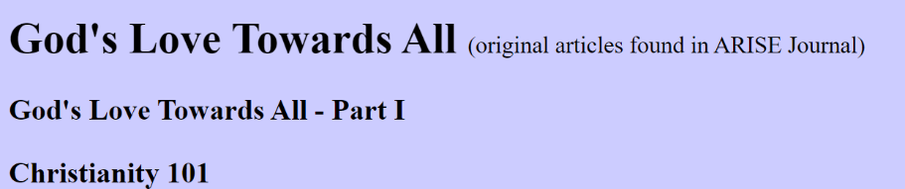

<http://www.ariseministry.com/content/short%20studies%20-%20topics/studies-gods-love.htm> (Website down, use Web Archive)

<http://web.archive.org/web/20081205003444/http://www.ariseministry.com/content/short%20studies%20-%20topics/studies-gods-love.htm>

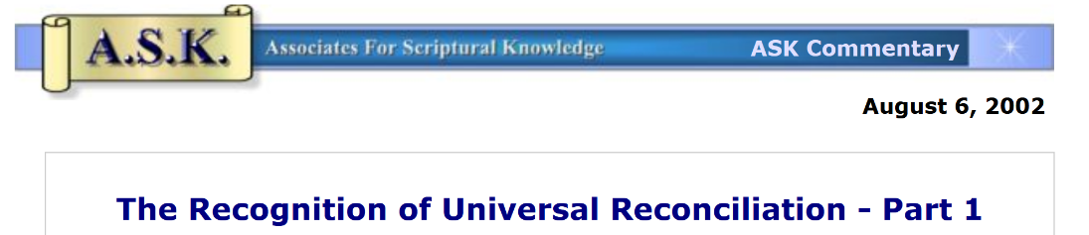

Associates For Scriptural Knowledge

<https://www.askelm.com>

December 28, 1996 to May 15, 2023.

[http://web.archive.org/web/20230000000000*/https://www.askelm.com](http://web.archive.org/web/20230000000000*/https://www.askelm.com)

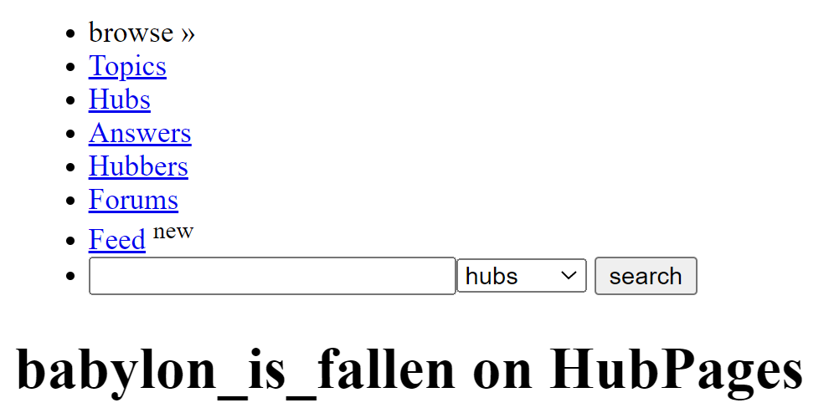

Babylon Is Fallen

<https://hubpages.com/profile/babylon_is_fallen> (Website is down, use Web Archive)

June 3, 2009 to April 5, 2011.

[http://web.archive.org/web/20101101000000*/https://hubpages.com/profile/babylon_is_fallen](http://web.archive.org/web/20101101000000*/https://hubpages.com/profile/babylon_is_fallen)

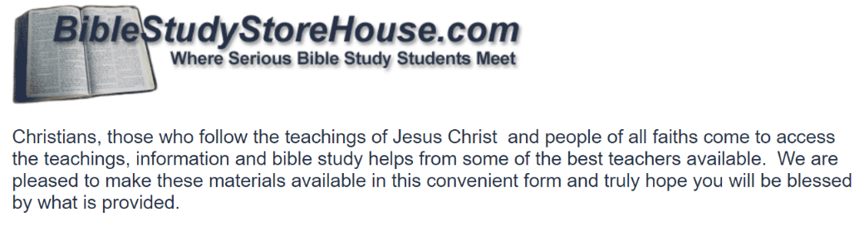

Bible Study Store House

<https://biblestudystorehouse.com> (Website is down, use Web Archive)

August 21, 2007 to October 4, 2022.

[http://web.archive.org/web/20101101000000*/www.biblestudystorehouse.com](http://web.archive.org/web/20101101000000*/www.biblestudystorehouse.com)

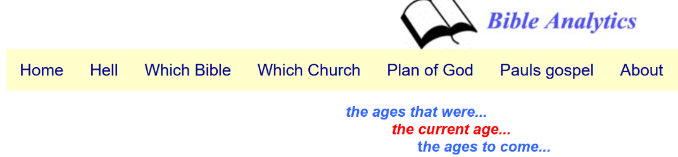

Bible Analytics

<https://bibleanalytics.ca> (Website is down, use Web Archive)

November 2, 2017 to March 25, 2023.

[http://web.archive.org/web/20181001000000*/http://bibleanalytics.ca](http://web.archive.org/web/20181001000000*/http://bibleanalytics.ca)



Bible Gateway

<https://biblegateway.com>

January 25, 1999 to May 19, 2023.

[http://web.archive.org/web/20181001000000*/https://biblegateway.com](http://web.archive.org/web/20181001000000*/https://biblegateway.com)



Bible Truths

[https://bible-truths.com](https://bible-truths.com/)

April 5, 2001 to May 15, 2023.

[http://web.archive.org/web/20230000000000*/https://www.askelm.com](http://web.archive.org/web/20230000000000*/https://www.askelm.com)



Biblical Universalism

<http://biblicaluniversalism.org/articles.html>

November 21, 2008 to January 26, 2022.

[http://web.archive.org/web/20230000000000*/https://www.askelm.com](http://web.archive.org/web/20230000000000*/https://www.askelm.com)

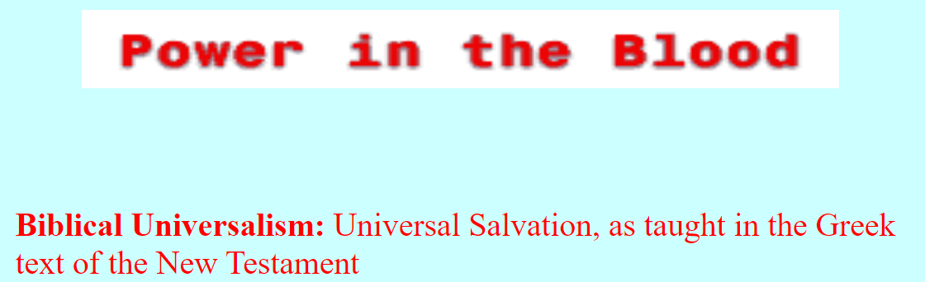

Biblical Universalist

<https://biblicaluniversalist.com> (Website down, use Web Archive)

June 10, 2005 to December 22, 2021.

<http://web.archive.org/web/20080617235544/http://www.biblicaluniversalist.com/>



Bushland Community Church

<https://urincluded2.com>

February 6, 2007 to January 5, 2014.

[http://web.archive.org/web/20081101000000*/http://www.urincluded2.com/](http://web.archive.org/web/20081101000000*/http://www.urincluded2.com/)

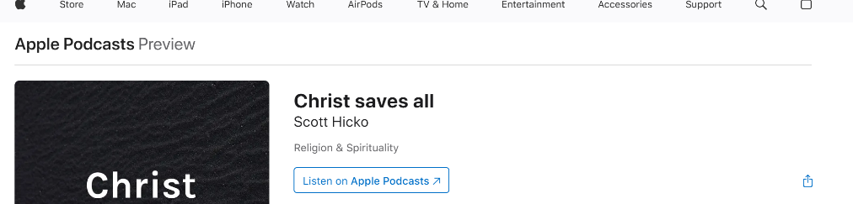

Christ Saves All Podcast

<https://podcasts.apple.com/us/podcast/christ-saves-all/id1490006911>

May 18 2023

[http://web.archive.org/web/20230000000000*/https://podcasts.apple.com/us/podcast/christ-saves-all/id1490006911](http://web.archive.org/web/20230000000000*/https://podcasts.apple.com/us/podcast/christ-saves-all/id1490006911)

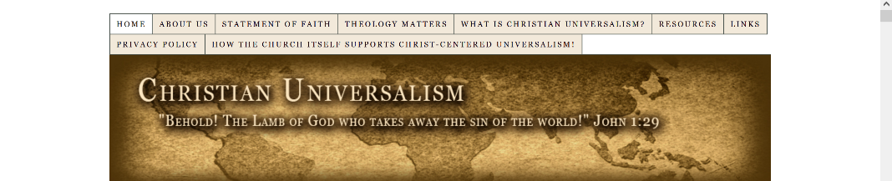

Christian Universalism

[https://www.christianuniversalism.com](https://www.christianuniversalism.com/)

January 23, 2002 and March 29, 2023.

[http://web.archive.org/web/20230000000000*/https://www.christianuniversalism.com](http://web.archive.org/web/20230000000000*/https://www.christianuniversalism.com)

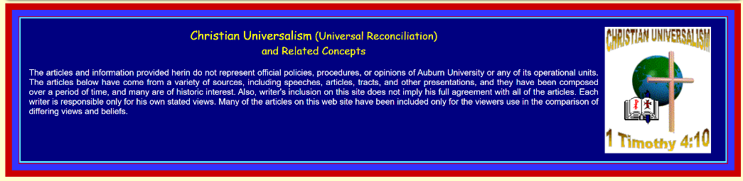

Christian Universalism Articles

<https://webhome.auburn.edu/~allenkc/univart.html> (Website is down, use Web Archive)

April 20, 2019 to July 6, 2022.

[http://web.archive.org/web/20190301000000*/http://webhome.auburn.edu/~allenkc/univart.html](http://web.archive.org/web/20190301000000*/http://webhome.auburn.edu/~allenkc/univart.html)

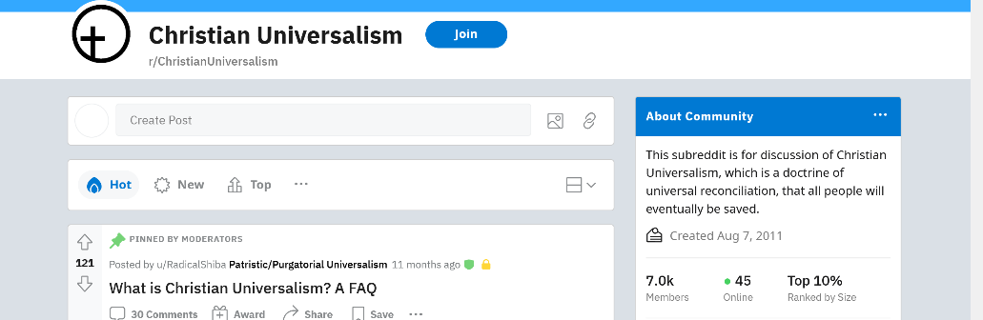

Christian Universalism Subreddit

<https://reddit.com/r/ChristianUniversalism/>

December 14, 2012 and May 10, 2023.

[http://web.archive.org/web/20230000000000*/https://reddit.com/r/ChristianUniversalism/](http://web.archive.org/web/20230000000000*/https://reddit.com/r/ChristianUniversalism/)



Christian Universalists Discord

<https://discordservers.com/server/491288908231868429>

May 18, 2023.

[https://web.archive.org/web/20230000000000*/https://discordservers.com/server/491288908231868429](https://web.archive.org/web/20230000000000*/https://discordservers.com/server/491288908231868429)



Christianity Without Insanity

[https://christianitywithoutinsanity.com](https://christianitywithoutinsanity.com/)

February 3, 2011 to April 20, 2023.

[http://web.archive.org/web/20130701000000*/https://christianitywithoutinsanity.com/](http://web.archive.org/web/20130701000000*/https://christianitywithoutinsanity.com/)

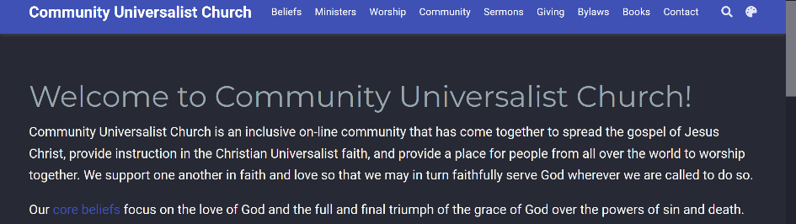

Community Universalist Church

[https://universalist.church](https://universalist.church/)

May 16, 2021 to February 6, 2023.

[https://web.archive.org/web/20230000000000*/https://universalist.church](https://web.archive.org/web/20230000000000*/https://universalist.church)

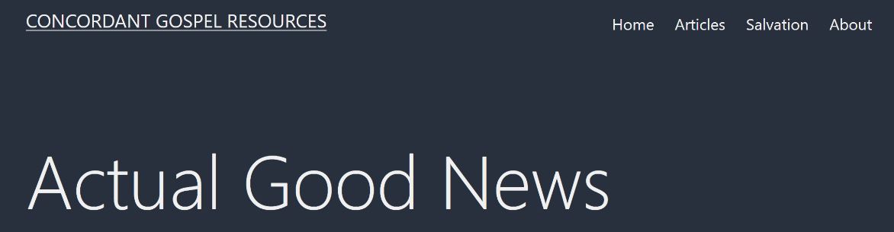

Concordant Gospel Resources

[https://concordantgospel.com](https://concordantgospel.com/)

March 23, 2021 to May 16, 2023.

[http://web.archive.org/web/20130701000000*/https://www.concordantgospel.com/](http://web.archive.org/web/20130701000000*/https://www.concordantgospel.com/)



Concordant Publishing

<https://concordant.org/unsearchable-riches/>

January 17, 1998 to May 14, 2023.

[http://web.archive.org/web/20130701000000*/https://www.concordant.org/](http://web.archive.org/web/20130701000000*/https://www.concordant.org/)



Daily Kos

<https://dailykos.com/blog/Eric%20Stetson>

December 7, 2011 to September 29, 2019.

[http://web.archive.org/web/20210601000000*/https://www.dailykos.com/blog/Eric%20Stetson](http://web.archive.org/web/20210601000000*/https://www.dailykos.com/blog/Eric%20Stetson)



Destined For Salvation Ministries

<https://destinedforsalvation.org>

December 9, 2004 and March 21, 2023.

[https://web.archive.org/web/20230000000000*/https://destinedforsalvation.org](https://web.archive.org/web/20230000000000*/https://destinedforsalvation.org)



Eclectic Orthodoxy

<https://afkimel.wordpress.com/essential-readings-on-universalism/>

October 17, 2013 to April 10, 2023.

[https://web.archive.org/web/20230000000000*/https://afkimel.wordpress.com/essential-readings-on-universalism/](https://web.archive.org/web/20230000000000*/https://afkimel.wordpress.com/essential-readings-on-universalism/)

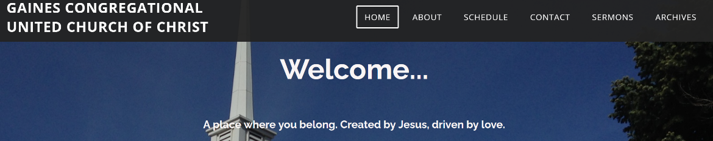

Gaines Congregational United Church of Christ

[www.gainescongregationalchurch.com](http://www.gainescongregationalchurch.com)

August 7, 2018 and December 7, 2022.

[http://web.archive.org/web/20210101000000*/http://www.gainescongregationalchurch.com](http://web.archive.org/web/20210101000000*/http://www.gainescongregationalchurch.com)



General Lutheran Church

<https://generallutheranchurch.org>

September 21, 2020 to March 14, 2023.

[http://web.archive.org/web/20230000000000*/https://generallutheranchurch.org](http://web.archive.org/web/20230000000000*/https://generallutheranchurch.org)

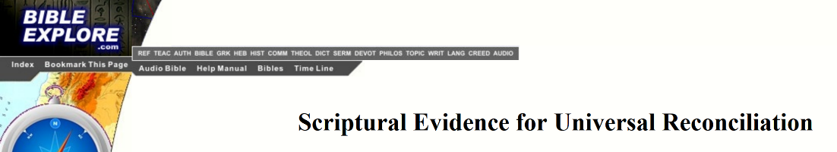

God Rules

<https://godrules.net/articles/universalism.htm>

August 18, 2013 to May 18, 2023.

[https://web.archive.org/web/20230000000000*/https://godrules.net/articles/universalism.htm](https://web.archive.org/web/20230000000000*/https://godrules.net/articles/universalism.htm)

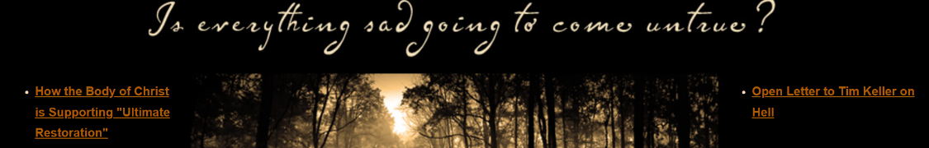

God’s Love Wins

[https://godslovewins.com](https://godslovewins.com/)

March 31, 2012 to March 4, 2023.

[http://web.archive.org/web/20101101000000*/http://godslovewins.com/](http://web.archive.org/web/20101101000000*/http://godslovewins.com/)



God’s Plan For All

<https://godsplanforall.com/>

March 21, 2008 to May 17, 2023.

[https://web.archive.org/web/20230000000000*/https://godsplanforall.com/](https://web.archive.org/web/20230000000000*/https://godsplanforall.com/)



God Saves All

<https://godsavesall.com>

April 13, 2004 to January 18, 2022.

[http://web.archive.org/web/20230000000000*/https://godsavesall.com](http://web.archive.org/web/20230000000000*/https://godsavesall.com)

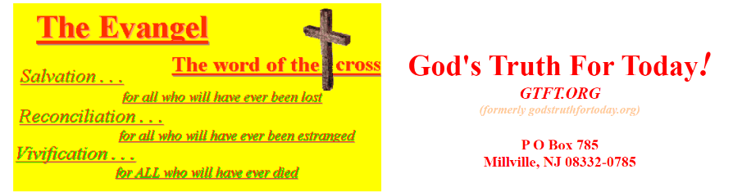

God’s Truth For Today

<https://gtft.org> (Website down, use Web Archive)

May 20, 2001 to March 27, 2023.

[https://web.archive.org/web/20111001000000*/http://www.gtft.org/](https://web.archive.org/web/20111001000000*/http://www.gtft.org/)

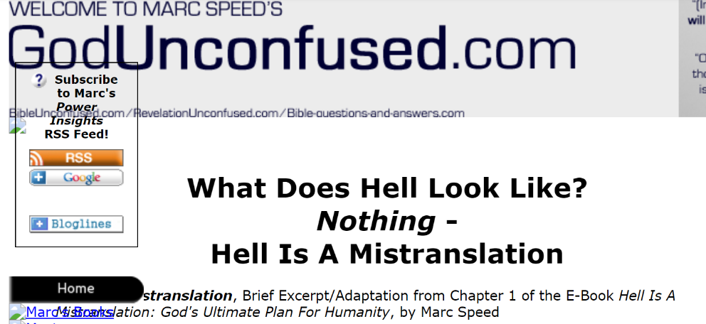

God Unconfused

<http://www.bible-questions-and-answers.com/what-does-hell-look-like.html>

March 16, 2012 and April 18, 2012.

[http://web.archive.org/web/20120615000000*/http://www.bible-questions-and-answers.com/what-does-hell-look-like.html](http://web.archive.org/web/20120615000000*/http://www.bible-questions-and-answers.com/what-does-hell-look-like.html)



Good News

[www.goodnewsinc.net](http://www.goodnewsinc.net)

December 6, 1998 to March 8, 2023.

[https://web.archive.org/web/20230000000000*/www.goodnewsinc.net](https://web.archive.org/web/20230000000000*/www.goodnewsinc.net)

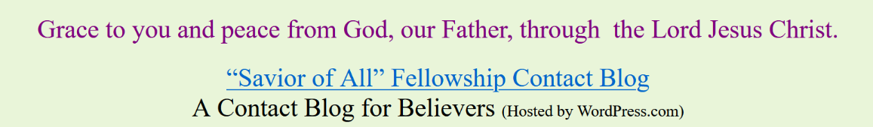

Good News Gospel

<https://goodnewsgospel.info/>

April 23, 2013 and March 14, 2023.

http://web.archive.org/web/20210601000000*/https://goodnewsgospel.info/

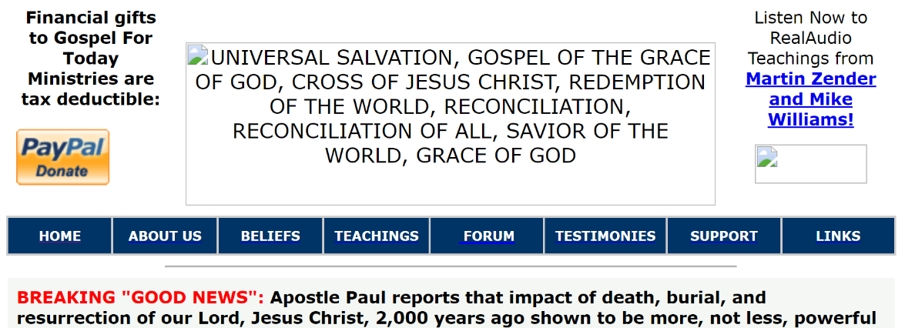

Gospel For Today Ministries

<https://gospelfortoday.org/>

December 3, 2001 to March 1, 2023.

[http://web.archive.org/web/20081101000000*/http://www.gospelfortoday.org/](http://web.archive.org/web/20081101000000*/http://www.gospelfortoday.org/)



Grace & Truth Online

<http://www.gracetruth.co.uk/> (Website down, use Web Archive)

March 18, 2014 to May 19, 2022.

<http://web.archive.org/web/20180906045339/http://www.gracetruth.co.uk/Publications/Mealand/Mealand_greatness.htm>



Greater Emmanuel

<http://greater-emmanuel.org>

December 7, 1998 to March 30, 2023.

[https://web.archive.org/web/20230000000000*/http://greater-emmanuel.org](https://web.archive.org/web/20230000000000*/http://greater-emmanuel.org)

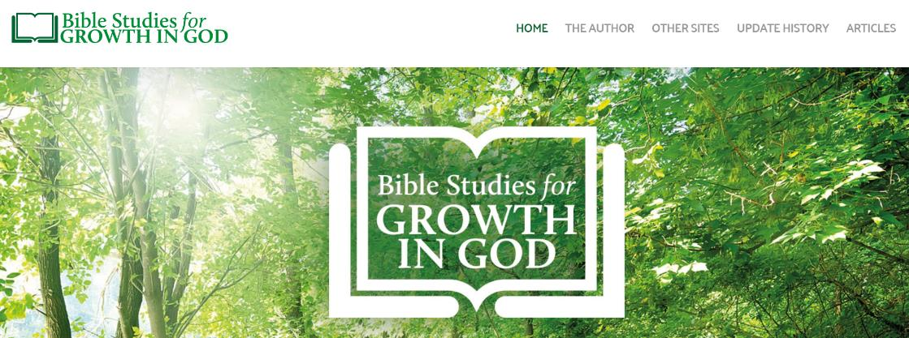

Growing With God

<http://www.growthingod.org.uk/universal-reconciliation.htm>

February 5, 2002 and April 2, 2023.

[http://web.archive.org/web/20080401000000*/http://www.growthingod.org.uk](http://web.archive.org/web/20080401000000*/http://www.growthingod.org.uk)



Harold Lovelace

<https://haroldlovelace.com>

April 15, 2005 to March 30, 2023.

[https://web.archive.org/web/20230000000000*/https://haroldlovelace.com](https://web.archive.org/web/20230000000000*/https://haroldlovelace.com)



Have We Lost Some of the Good News?

<https://gospel-truth4all.blogspot.com/>

May 3, 2017 to May 18, 2023.

[http://web.archive.org/web/20230000000000*/https://gospel-truth4all.blogspot.com/](http://web.archive.org/web/20230000000000*/https://gospel-truth4all.blogspot.com/)

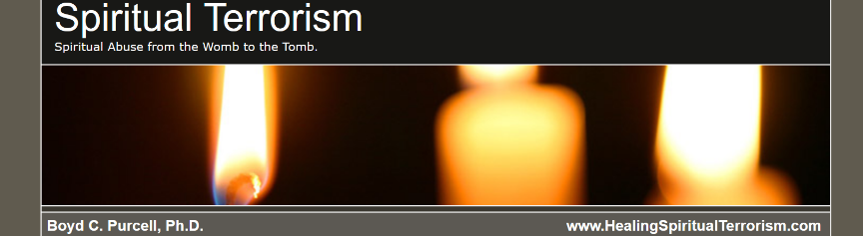

Healing Spiritual Terrorism

<https://healingspiritualterrorism.com> (Website down, use Web Archive)

November 12, 2009 to May 12, 2023.

[http://web.archive.org/web/20130701000000*/http://healingspiritualterrorism.com/](http://web.archive.org/web/20130701000000*/http://healingspiritualterrorism.com/)



Hearing the Truth of God

<https://hearingthetruthofgod.com>

March 23, 2007 to April 8, 2023.

[http://web.archive.org/web/20160901000000*/https://hearingthetruthofgod.com/](http://web.archive.org/web/20160901000000*/https://hearingthetruthofgod.com/)

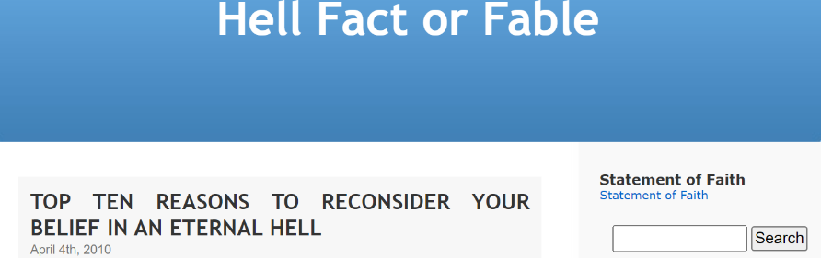

Hell Fact or Fable

<http://hell-fact-or-fable.com/>

November 2, 2007 to July 1, 2019.

[http://web.archive.org/web/20190901000000*/http://hell-fact-or-fable.com/](http://web.archive.org/web/20190901000000*/http://hell-fact-or-fable.com/)



Hope Beyond Hell

<https://hopebeyondhell.net>

January 21, 2007 to May 7, 2023.

[https://web.archive.org/web/20230000000000*/https://hopebeyondhell.net](https://web.archive.org/web/20230000000000*/https://hopebeyondhell.net)



If God Could Save Everyone - Would He?

<https://godskingdom.org/studies/books/if-god-could-save-everyone-would-he/chapter-1-if-god-could-save-everyone-would-he/>

December 2, 2020 to October 15, 2022.

[http://web.archive.org/web/20230000000000*/https://godskingdom.org/studies/books/if-god-could-save-everyone-would-he/chapter-1-if-god-could-save-everyone-would-he/](http://web.archive.org/web/20230000000000*/https://godskingdom.org/studies/books/if-god-could-save-everyone-would-he/chapter-1-if-god-could-save-everyone-would-he/)



Inclusion

<https://inclusion.ws> (Website down, use Web Archive)

December 9, 2004 to December 8, 2021.

[http://web.archive.org/web/20081101000000*/https://inclusion.ws](http://web.archive.org/web/20081101000000*/https://inclusion.ws)

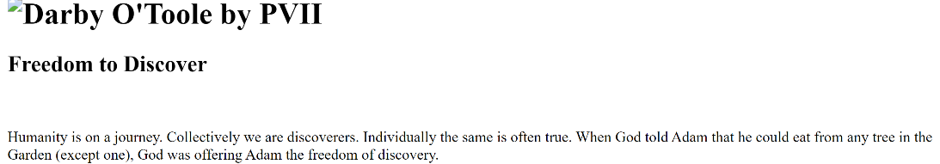

Infinite Grace

<https://infinite-grace.com> (Website down, use Web Archive)

<http://web.archive.org/web/20160225083932/http://www.infinite-grace.com/>



Inner Monastery

<https://inner-monastery.blogspot.com/>

August 14, 2013 to October 31, 2022.

[https://web.archive.org/web/20230000000000*/https://inner-monastery.blogspot.com/](https://web.archive.org/web/20230000000000*/https://inner-monastery.blogspot.com/)

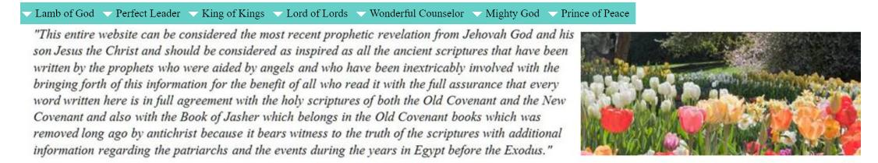

Jesus Call To Freedom

<http://www.jesuscalltofreedom.com/jesus-christ-will-save-all-mankind.html>

May 18 2023

[http://web.archive.org/web/20230000000000*/http://www.jesuscalltofreedom.com/jesus-christ-will-save-all-mankind.html](http://web.archive.org/web/20230000000000*/http://www.jesuscalltofreedom.com/jesus-christ-will-save-all-mankind.html)

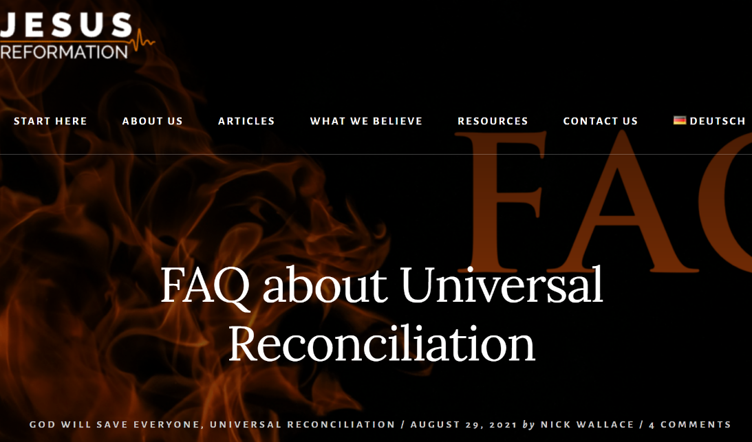

Jesus Reformation

<https://www.jesusreformation.org/en/2021/faq-about-universal-reconciliation/>

September 10, 2021 to May 12, 2023.



Justin Aptaker

<https://justinaptaker.wordpress.com/2019/05/11/the-argument-from-beauty-another-defense-of-christian-universalism-section-i/>

May 8, 2019 to February 8, 2023.

<http://web.archive.org/web/20230208200011/https://justinaptaker.wordpress.com/>



Leaves in the Wind

<https://davidbentleyhart.substack.com/p/an-announcement>

March 11, 2023 to May 18, 2023

[https://web.archive.org/web/20230000000000*/https://davidbentleyhart.substack.com/p/an-announcement](https://web.archive.org/web/20230000000000*/https://davidbentleyhart.substack.com/p/an-announcement)



Lighthouse Library International

<http://www.lighthouselibrary.com/searchdb.php?what=author&searchfor=|BEAUCHEMIN,%20GERRY|&type=&show=titles> (Website down, use Web Archive)

September 26, 2001 to March 30, 2023.

[http://web.archive.org/web/20101201000000*/https://www.lighthouselibrary.com/](http://web.archive.org/web/20101201000000*/https://www.lighthouselibrary.com/)

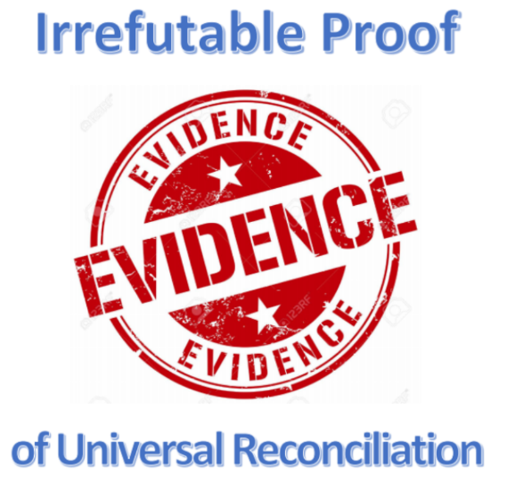

Live Faith TV

[https://livefaith.tv](https://livefaith.tv/)

October 27, 2001 to May 14, 2023.

[http://web.archive.org/web/20181001000000*/https://livefaith.tv](http://web.archive.org/web/20181001000000*/https://livefaith.tv)



Lord of Life Ministries

<http://www.lordoflifeministries.com/>

July 9, 2009 to September 29, 2022.

[http://web.archive.org/web/20101201000000*/http://www.lordoflifeministries.com/](http://web.archive.org/web/20101201000000*/http://www.lordoflifeministries.com/)



Love Unrelenting

<https://loveunrelenting.com>

March 25, 2022 to March 30, 2023.

[https://web.archive.org/web/20230000000000*/https://loveunrelenting.com](https://web.archive.org/web/20230000000000*/https://loveunrelenting.com)



Love Wins

<https://robbell.com/book/love-wins/>

May 10, 2021 to March 20, 2023.

[http://web.archive.org/web/20230000000000*/https://robbell.com/book/love-wins/](http://web.archive.org/web/20230000000000*/https://robbell.com/book/love-wins/)

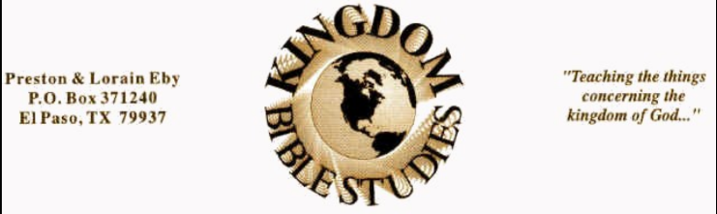

Kingdom Bible Studies

<https://www.kingdombiblestudies.org>

March 20, 2003 to May 8, 2023.

[https://web.archive.org/web/20230000000000*/https://www.kingdombiblestudies.org](https://web.archive.org/web/20230000000000*/https://www.kingdombiblestudies.org)

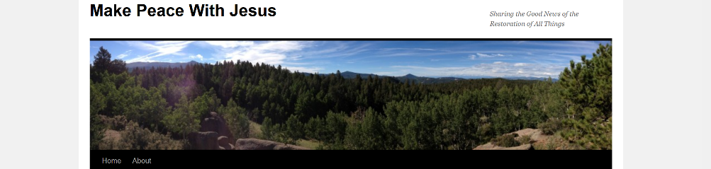

Make Peace With Jesus

<https://makepeacewithjesus.org/>

May 14, 2011 to May 12, 2023.

[https://web.archive.org/web/20230000000000*/https://makepeacewithjesus.org/](https://web.archive.org/web/20230000000000*/https://makepeacewithjesus.org/)



Martin Zender

<http://www.martinzender.com/QA.htm>

January 26, 2002 to May 15, 2023.

[http://web.archive.org/web/20160901000000*/http://www.martinzender.com/](http://web.archive.org/web/20160901000000*/http://www.martinzender.com/)



Merciful Truth

<https://mercifultruth.com>

February 3, 2006 to May 2, 2023.

[https://web.archive.org/web/20230000000000*/https://mercifultruth.com](https://web.archive.org/web/20230000000000*/https://mercifultruth.com)

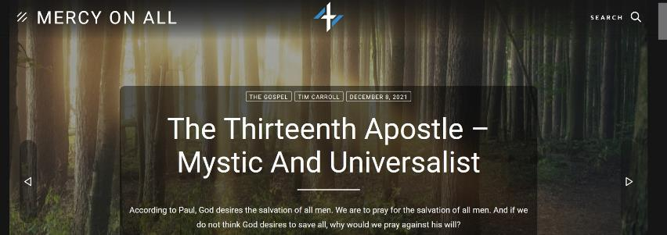

Mercy On All

<https://mercyonall.org>

June 7, 2020 to May 10, 2023.

[https://web.archive.org/web/20230000000000*/https://mercyonall.org](https://web.archive.org/web/20230000000000*/https://mercyonall.org)

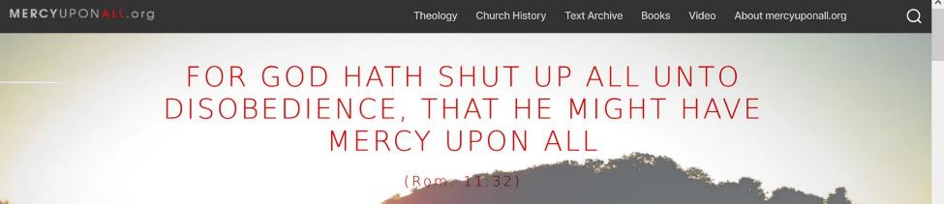

Mercy Upon All

<https://mercyuponall.org>

January 18, 2016 to May 6, 2023.

[https://web.archive.org/web/20230000000000*/https://mercyuponall.org](https://web.archive.org/web/20230000000000*/https://mercyuponall.org)



Niq Ruud

<https://niqruud.com>

June 12, 2020 and February 4, 2023.

http://web.archive.org/web/20210101000000*/https://niqruud.com



Overcomers

<https://overcomers.ca/A_Letter_To_The_Body_Of_Christ.html>

January 12, 2007 to November 23, 2022.

[http://web.archive.org/web/20080401000000*/https://overcomers.ca](http://web.archive.org/web/20080401000000*/https://overcomers.ca)



Phil Henry Power Gospel

<https://philhenrypowergospel.org>

May 26, 2016 to May 5, 2023.

[https://web.archive.org/web/20230000000000*/https://philhenrypowergospel.org](https://web.archive.org/web/20230000000000*/https://philhenrypowergospel.org)

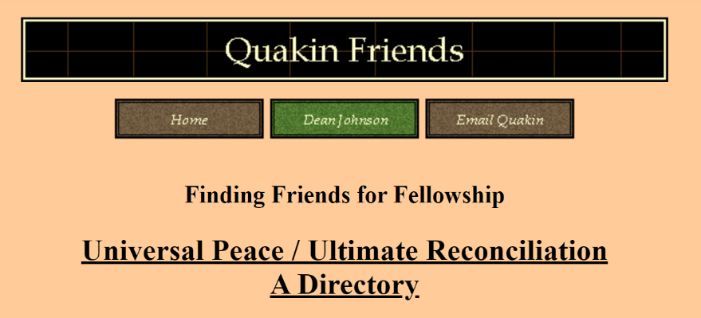

Quakin Friends

<https://www.angelfire.com/dc/universalism/form.html> (Website down, use Web Archive)

August 11, 2005 to October 31, 2020.

[https://web.archive.org/web/20111001000000*/https://www.angelfire.com/dc/universalism/form.html](https://web.archive.org/web/20111001000000*/https://www.angelfire.com/dc/universalism/form.html)

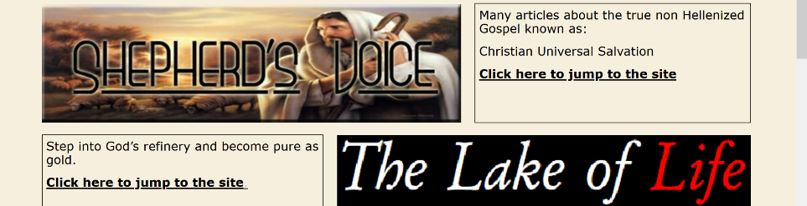

Radical Reaction

<https://radical-reaction.com>

September 25, 2015 to December 22, 2021.

[https://web.archive.org/web/20230000000000*/https://radical-reaction.com](https://web.archive.org/web/20230000000000*/https://radical-reaction.com)

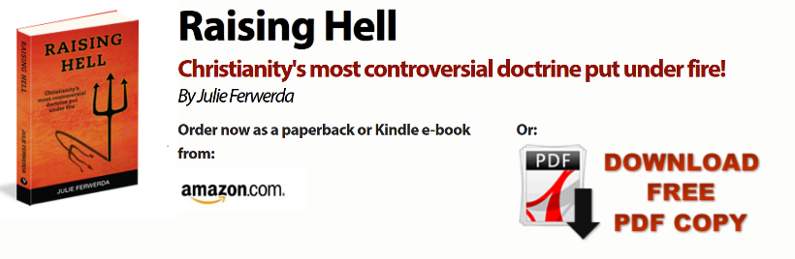

Raising Hell

<http://www.raisinghellbook.com/>

July 10, 2011 to April 16, 2023.

[http://web.archive.org/web/20230000000000*/http://www.raisinghellbook.com/](http://web.archive.org/web/20230000000000*/http://www.raisinghellbook.com/)



Restore All Things

[http://www.restoreallthings.org](http://www.restoreallthings.org/) (Website is down, use Web Archive)

November 30, 2001 to October 26, 2022.

<http://web.archive.org/web/20100315141241/http://www.restoreallthings.org/>



Richard Wayne Garganta

<http://richardwaynegarganta.com>

November 17, 2006 to May 3, 2023.

[https://web.archive.org/web/20230000000000*/http://richardwaynegarganta.com](https://web.archive.org/web/20230000000000*/http://richardwaynegarganta.com)



Salvation Of All

<https://salvationofall-av.org>

August 11, 2007 to March 31, 2023.

[https://web.archive.org/web/20230000000000*/https://salvationofall-av.org](https://web.archive.org/web/20230000000000*/https://salvationofall-av.org)

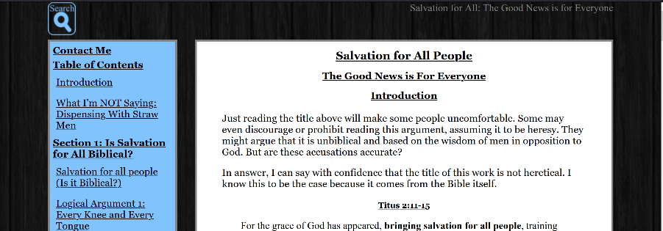

Salvation For All

[https://salvationforall.org](https://salvationforall.org/)

September 4, 2011 to April 24, 2023.

[https://web.archive.org/web/20230000000000*/https://salvationforall.org](https://web.archive.org/web/20230000000000*/https://salvationforall.org)

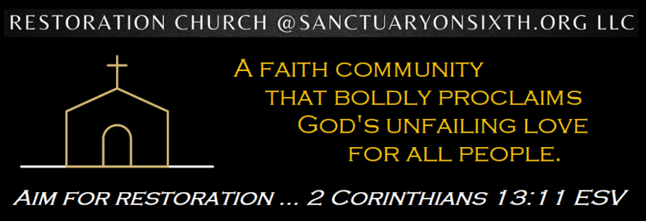

Sanctuary on Sixth

[https://sanctuaryonsixth.org](https://sanctuaryonsixth.org/)

September 26, 2021 to March 24, 2023.

[http://web.archive.org/web/20230000000000*/https://sanctuaryonsixth.org/](http://web.archive.org/web/20230000000000*/https://sanctuaryonsixth.org/)



Savior of All

[https://saviorofall.wordpress.com](https://saviorofall.wordpress.com/)

February 8, 2011 to April 6, 2023.

http://web.archive.org/web/20210601000000*/https://saviorofall.wordpress.com/



Saviour Of All

[https://saviourofall.org](https://saviourofall.org/)

April 12, 2008 to March 21, 2023.

[https://web.archive.org/web/20230000000000*/https://salvationforall.org](https://web.archive.org/web/20230000000000*/https://salvationforall.org)



Savior of the World

<https://savioroftheworld.net/>

November 6, 2002 to October 23, 2022.

<http://web.archive.org/web/20160304195420/http://savioroftheworld.net/>

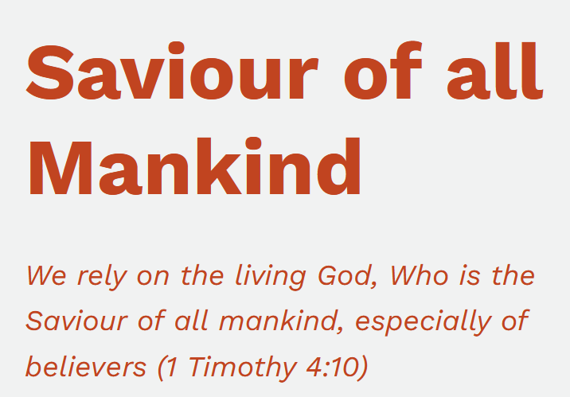

Saviour of all Mankind

<https://saviourofallmankind.wordpress.com>

February 4, 2023 to May 17, 2023

[http://web.archive.org/web/20210601000000*/https://saviourofallmankind.wordpress.com](http://web.archive.org/web/20210601000000*/https://saviourofallmankind.wordpress.com)



Sigler

[https://sigler.org](https://sigler.org/)

February 5, 1998 to May 17, 2023.

[https://web.archive.org/web/20230000000000*/https://sigler.org](https://web.archive.org/web/20230000000000*/https://sigler.org)



Spiritual Brewpub

<https://spiritualbrewpub.com>

December 25, 2021 and May 12, 2023.

http://web.archive.org/web/20210601000000*/https://spiritualbrewpub.com



Study Shelf

<http://pilkingtonandsons.com/hell.htm>

June 8, 2004 and April 5, 2023.

http://web.archive.org/web/20210601000000*/http://pilkingtonandsons.com/hell.htm

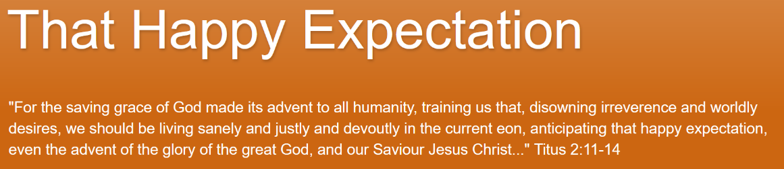

That Happy Expectation

<https://thathappyexpectation.blogspot.com>

February 17, 2016 to March 14, 2023.

[http://web.archive.org/web/20181001000000*/https://thathappyexpectation.blogspot.com/](http://web.archive.org/web/20181001000000*/https://thathappyexpectation.blogspot.com/)

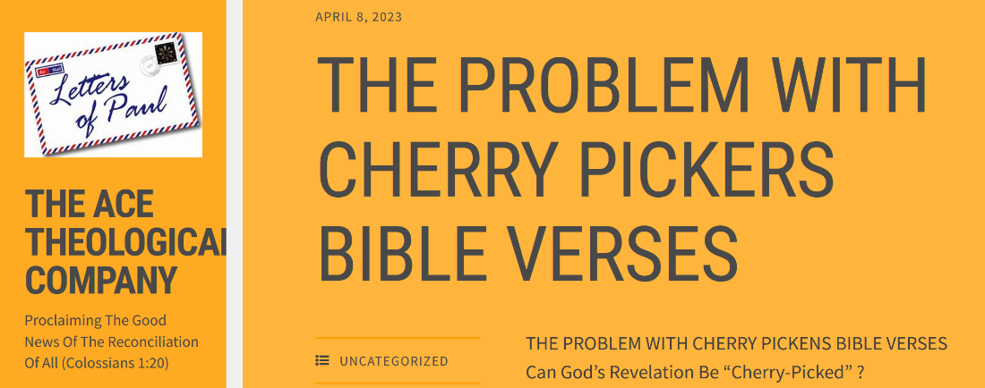

The Ace Theological Company

<https://acetheologicalco.wordpress.com>

May 27, 2021 to April 22, 2023.

[http://web.archive.org/web/20181001000000*/https://acetheologicalco.wordpress.com/](http://web.archive.org/web/20181001000000*/https://acetheologicalco.wordpress.com/)

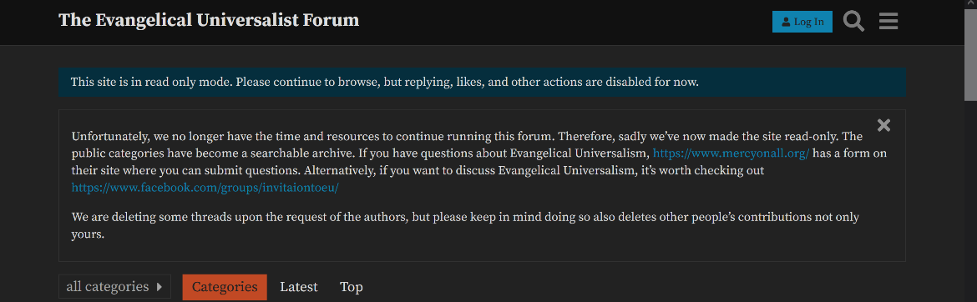

The Evangelical Universalist Forum

[https://forum.evangelicaluniversalist.com](https://forum.evangelicaluniversalist.com/)

July 11, 2018 and May 13, 2023.

[https://web.archive.org/web/20230000000000*/https://forum.evangelicaluniversalist.com](https://web.archive.org/web/20230000000000*/https://forum.evangelicaluniversalist.com)

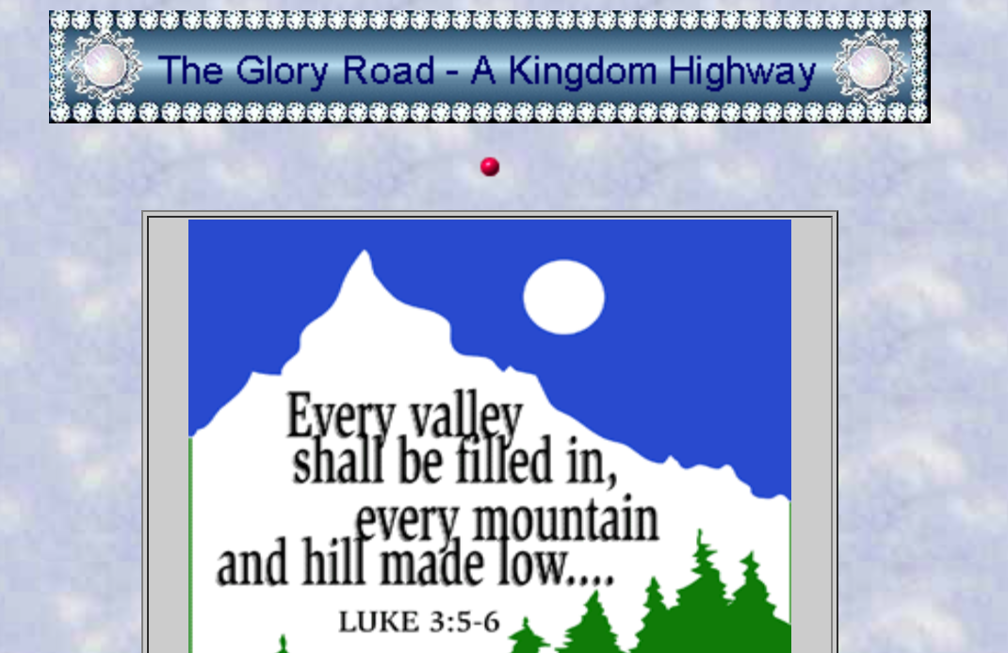

The Glory Road

<https://thegloryrd.com> (Website down, use Web Archive)

December 19, 2007 to April 28, 2022.

[http://web.archive.org/web/20151101000000*/http://thegloryrd.com/](http://web.archive.org/web/20151101000000*/http://thegloryrd.com/)



The Harvest Herald

<https://harvestherald.com/good-tidings-of-great-joy.html>

June 5, 2002 to May 6, 2023.

[http://web.archive.org/web/20200501000000*/https://harvestherald.com](http://web.archive.org/web/20200501000000*/https://harvestherald.com)

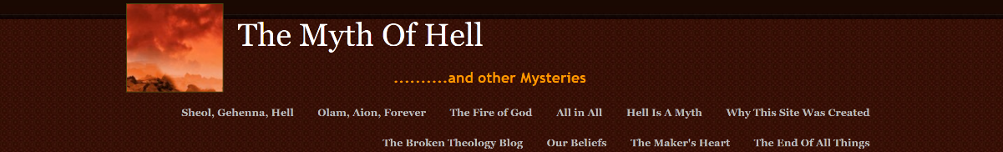

The Myth of Hell

[https://hell-is-a-myth.webs.com](https://hell-is-a-myth.webs.com/)

November 6, 2011 to September 26, 2022.

[https://web.archive.org/web/20021015000000*/https://hell-is-a-myth.webs.com](https://web.archive.org/web/20021015000000*/https://hell-is-a-myth.webs.com)

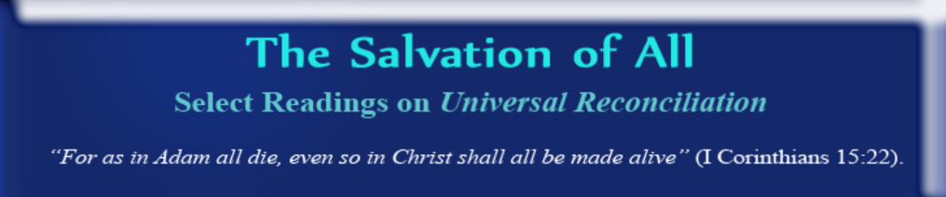

The Salvation of All

<https://salvationofall.wordpress.com>

January 31, 2009 and November 5, 2022.

http://web.archive.org/web/20210601000000*/https://salvationofall.wordpress.com



The Universalist Heretic

[https://universalistheretic.blogspot.com](https://universalistheretic.blogspot.com/)

February 8, 2022 to May 12, 2023.

[http://web.archive.org/web/20181001000000*/https://universalistheretic.blogspot.com/](http://web.archive.org/web/20181001000000*/https://universalistheretic.blogspot.com/)



Theological Studies

<https://www.theologicalstudies.org.uk/article_universalism_bauckham.html#2>

August 20, 2002 to May 8, 2023.

[http://web.archive.org/web/20230000000000*/https://www.theologicalstudies.org.uk](http://web.archive.org/web/20230000000000*/https://www.theologicalstudies.org.uk)

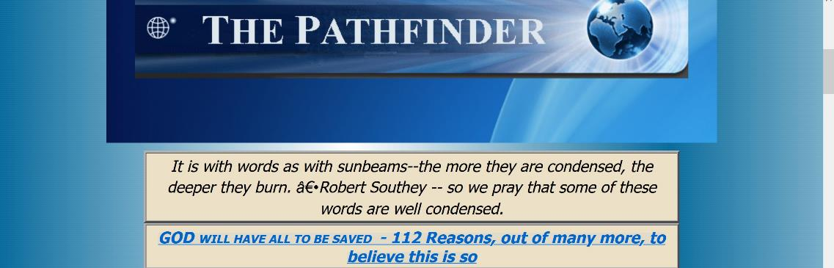

The Pathfinder

[https://godfire.net](https://godfire.net/)

September 16, 2000 to May 13, 2023.

[https://web.archive.org/web/20021015000000*/https://godfire.net](https://web.archive.org/web/20021015000000*/https://godfire.net)

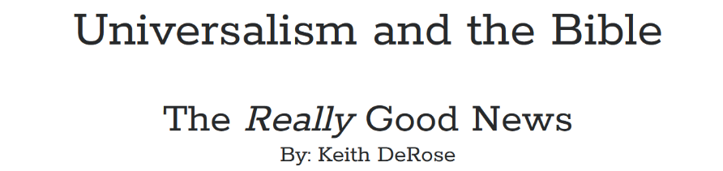

The Really Good News

<https://campuspress.yale.edu/keithderose/1129-2/>

April 17, 2016 to May 12, 2023.



The Sanctuary

<https://thesanctuarydenver.org>

September 6, 2011 and May 14, 2023.

[http://web.archive.org/web/20101101000000*/https://thesanctuarydenver.org/](http://web.archive.org/web/20101101000000*/https://thesanctuarydenver.org/)

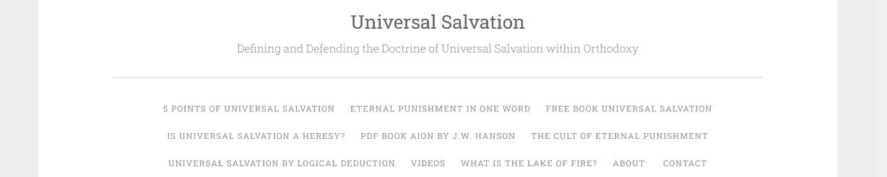

The Total Victory of Christ

[https://thetotalvictoryofchrist.wordpress.com](https://thetotalvictoryofchrist.wordpress.com/)

December 15, 2019 to March 20, 2023.

[https://web.archive.org/web/20021015000000*/https://thetotalvictoryofchrist.wordpress.com](https://web.archive.org/web/20021015000000*/https://thetotalvictoryofchrist.wordpress.com)

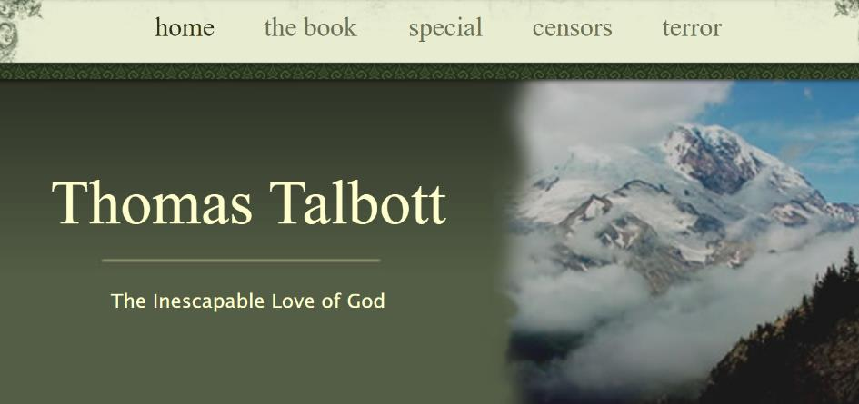

Thomas Talbott

<http://www.thomastalbott.com>

August 12, 2007 to April 16, 2023.

[http://web.archive.org/web/20081101000000*/http://www.thomastalbott.com](http://web.archive.org/web/20081101000000*/http://www.thomastalbott.com)



Through the Veil

<https://jwirth.com/wordpress> (Website down, use web archive)

Saved by 1 person on May 13, 2008. Thank you! :D

[http://web.archive.org/web/20081101000000*/http://www.jwirth.com/wordpress/](http://web.archive.org/web/20081101000000*/http://www.jwirth.com/wordpress/)

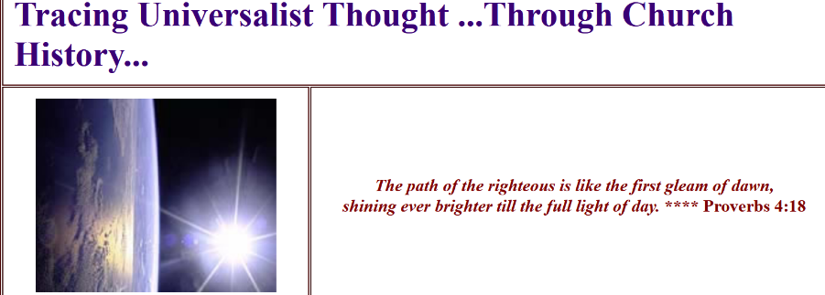

TL Christ

<https://www.tlchrist.info/universalists.html>

June 18, 2008 to July 15, 2022.

[https://web.archive.org/web/20021015000000*/https://www.tlchrist.info/universalists.html](https://web.archive.org/web/20021015000000*/https://www.tlchrist.info/universalists.html)



Triumph Of Mercy

[https://www.triumphofmercy.com](https://www.triumphofmercy.com/)

August 7, 2018 to May 1, 2023.

[http://web.archive.org/web/20080401000000*/https://www.triumphofmercy.com/](http://web.archive.org/web/20080401000000*/https://www.triumphofmercy.com/)

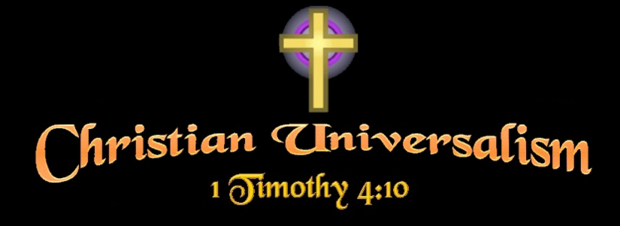

True Grace Ministries

<https://tgulcm.tripod.com/cu/univart.html>

May 8, 2006 to February 7, 2023.

[https://web.archive.org/web/20021015000000*/https://tgulcm.tripod.com/cu/univart.html](https://web.archive.org/web/20021015000000*/https://tgulcm.tripod.com/cu/univart.html)

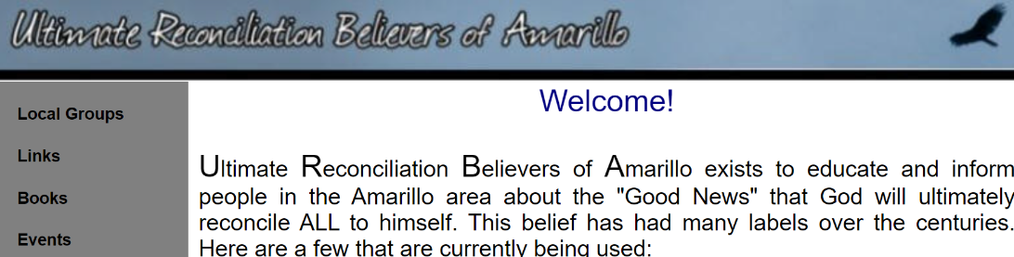

Ultimate Reconciliation Believers of Amarillo

<https://christaslife.org> (Website down, use Web Archive)

March 6, 2000 to November 5, 2022.

[http://web.archive.org/web/20081101000000*/http://www.christaslife.org/](http://web.archive.org/web/20081101000000*/http://www.christaslife.org/)



Universalist National Memorial Church

<https://universalist.org>

December 4, 2000 to May 6, 2023.

[http://web.archive.org/web/20230000000000*/https://www.universalist.org/](http://web.archive.org/web/20230000000000*/https://www.universalist.org/)

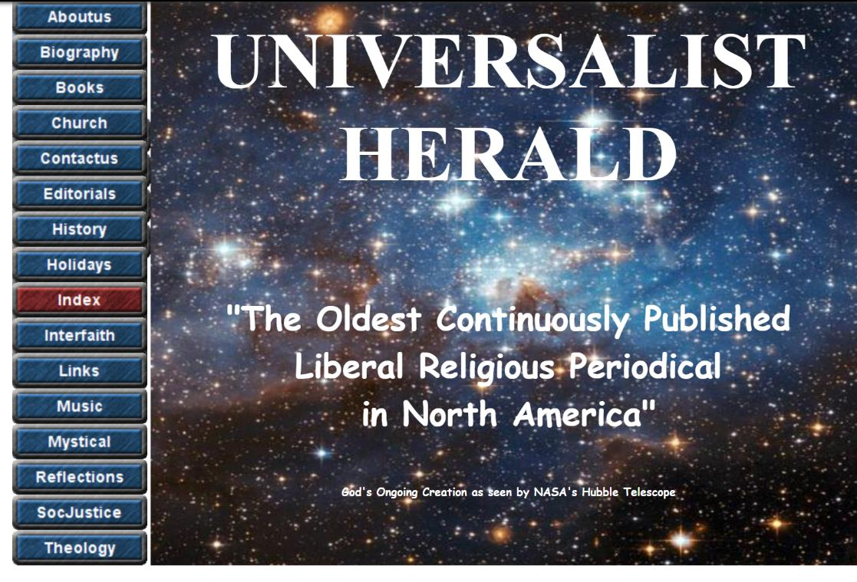

Universalist Herald

<https://universalist-herald.net> (Website is down, use Web Archive)

August 24, 2004 to December 10, 2022.

[http://web.archive.org/web/20190901000000*/https://universalist-herald.net](http://web.archive.org/web/20190901000000*/https://universalist-herald.net)



Universal Restoration Ministries

<https://universalrestoration.org>

December 13, 2020 to March 25, 2023.

[http://web.archive.org/web/20230000000000*/https://universalrestoration.org/](http://web.archive.org/web/20230000000000*/https://universalrestoration.org/)

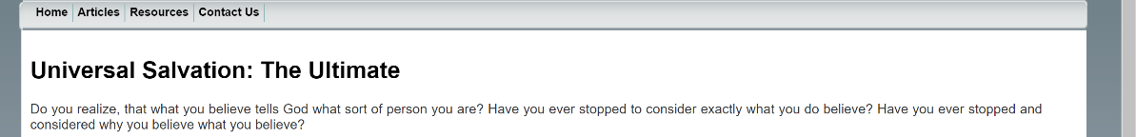

Universal Salvation: The Ultimate

<https://universalsalvation.org> (Website down, use Web Archive)

November 22, 2009 to September 23, 2019.

[https://web.archive.org/web/20111001000000*/http://www.universalsalvation.org/index.htm](https://web.archive.org/web/20111001000000*/http://www.universalsalvation.org/index.htm)



Universal Salvation University

<http://richardwaynegarganta.com/universalsalvation.htm>

March 6, 2007 to December 9, 2021.

[http://web.archive.org/web/20200501000000*/http://richardwaynegarganta.com/universalsalvation.htm](http://web.archive.org/web/20200501000000*/http://richardwaynegarganta.com/universalsalvation.htm)



URfriendly Reflections

[https://deanjohnson.blogspot.com](https://deanjohnson.blogspot.com/)

July 17, 2012 to January 9, 2022.

[https://web.archive.org/web/20021015000000*/https://deanjohnson.blogspot.com/](https://web.archive.org/web/20021015000000*/https://deanjohnson.blogspot.com/)



Vision Fellowship Ministries

<https://vfmi.org>

September 7, 2011 to February 20, 2023.

[http://web.archive.org/web/20230000000000*/https://www.vfmi.org/](http://web.archive.org/web/20230000000000*/https://www.vfmi.org/)

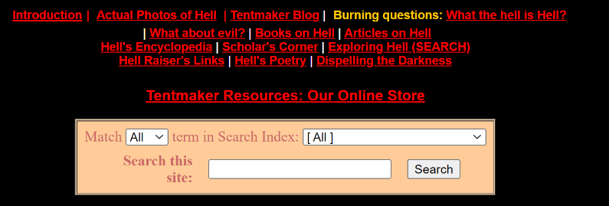

What The Hell Is Hell

<https://what-the-hell-is-hell.com>

November 27, 1999 to September 28, 2021.

<http://web.archive.org/web/20080712021034/http://www.what-the-hell-is-hell.com/>

_______

To Search:

http://vagabondgroup.com/julieferwerda/2011/07/07/jesus-saves-all-or-he-saves-none/

https://simplesalvation.org/n/christian_universalism_universal_reconciliation_websites.html

https://www.universalist-herald.org/links.html

https://forum.evangelicaluniversalist.com/t/universalist-web-sites/1438/2

https://en.m.wikipedia.org › wikiChristian Universalist Church of America

Bloggerhttp://evangelicaluniversalist.blogspot.com › ...NEWS: Possible Christian Universalist Forum

https://www.unionlife.org/download/MAY_2011%20CUA.pdf

https://web.archive.org/web/20230000000000*/even%20hitler%20christian%20universalism

https://www.reddit.com/r/ChristianUniversalism/comments/13pc1pl/100_christian_universalism_websites/

Swimming-Extent9366

1 day ago

Does anyone else remember a Universalist forum called even hitler? I remember going on it once or twice, but I can’t find any information on it.

https://oratiofidelis.wordpress.com/

<http://jesussavesall.org/>

<http://www.biblestudentsnotebook.com/bsn852.pdf>

<https://www.iswasandwillbe.com/what-is-aionios-life/>

<https://u.pcloud.link/publink/show?code=XZQB7NkZgFVKVp3HMabH9BWCf6GOUpKnRADy>

<https://livefaith.tv/>

<https://www.ancient-hebrew.org/27_eternity.html> (Website down

<https://goedbericht.nl/english/romans-1411-every-knee-and-every-tongue/>

<https://www.reddit.com/r/ConcordantBelievers/comments/l7v56t/some_concordant_resources/>

<https://tgulcm.tripod.com/cu/hypocrisy.htm>

<https://www.concordantgospel.com/>

<https://www.christtheliberator.org/>

<https://evangelicaluniversalist.blogspot.com/2008/07/trinity-and-why-it-is-big-issue.html>

<https://sovereign-love.blog/>

<https://www.researchgate.net/publication/342363189_Annihilation_or_salvation_A_philosophical_case_for_preferring_universalism_to_annihilationism>

Facebook

<https://www.facebook.com/people/Christian-Universalist-Association/100064686551511/>

<https://twitter.com/cuaorg>

<https://www.instagram.com/thechristianuniversalist/>

Pinterest

<https://www.pinterest.ca/pin/theologies--398920479477244202/>

Lulu

<https://www.lulu.com/shop/jw-hanson-dd/universalism/paperback/product-1nwpdwg.html?q=christian+universalism&page=1&pageSize=4>

<https://www.reddit.com/r/ChristianUniversalism/comments/wegy7z/lets_compile_some_universalist_congregations/>

<https://www.linkedin.com/company/cuaorg>

<https://www.tumblr.com/fierysword/708663259763556352/i-cannot-believe-that-god-wants-punishment-to-go>

<https://wordpress.com/tag/universalism>

<https://canonofreason.com/2022/12/17/the-case-for-universalism/>

<https://www.barnesandnoble.com/w/christian-universalism-maybe-god-isnt-such-a-bad-guy-after-all-richard-harold-goyette/1120025301?ean=9781500651107>

<https://www.overdrive.com/media/5524444/grace-saves-all>

<https://books.google.ca/books/about/Fifty_Notable_Years.html?id=567EDwAAQBAJ&redir_esc=y>

<https://brandyanderson.net/2023/05/20/refining-fire/>

<https://github.com/AzuxirenLeadGuy/Aionian-Project>

<https://www.chapters.indigo.ca/en-ca/books/that-all-shall-be-saved/9780300258486-item.html>

<https://www.roblox.com/users/4300921012/profile>

<https://www.roblox.com/groups/create>

<https://www.habbo.com/community/photos>

<https://www.amazon.ca/Christian-Universalism-Gods-Good-People/dp/0967063183/ref=sr_1_3?crid=FGNIPLFSE73U&keywords=christian+universalism&qid=1686022115&s=books&sprefix=chris%2Cstripbooks%2C856&sr=1-3>

<https://www.mcnallyrobinson.com/9789355894670/john-g-adams/fifty-notable-years-views-of-the-ministry-of-christian-universalism-during-the-last-half-century-with-biographical-sketches?blnBKM=1>

<https://books.google.ca/books?id=n-ADswEACAAJ&source=gbs_book_other_versions>

<https://www.deviantart.com/animeninjanippon/art/Christian-Universalism-Stamp-430678746>

<https://owlcation.com/humanities/Why-I-Dont-Believe-in-an-Eternal-Hell>

<https://www.christianuniversalism.org/>

<https://www.publicpeople.org/what-is-christian-universalism.htm>

Discussion Forums

<https://christianchat.com/bible-discussion-forum/christian-universalism.20390/>

<https://christianity.stackexchange.com/questions/525/what-is-the-biblical-basis-for-universal-salvation>

<https://www.kobo.com/us/en/ebook/hope-beyond-hell-the-righteous-purpose-of-god-s-judgment>

<http://fatherslove.freeforums.org/index.php>

‘

Youtube

The Total Victory of Christ

Aion Part 1 | Eternal Punishment is Not Biblical

<https://www.youtube.com/watch?v=p77xXIZyP34>

Max Borges

aionios, the Greek word translated as "eternal" and "everlasting" in the Bible (eternal hell?)

<https://www.youtube.com/watch?v=_kfKQJfT0C8>

Biblical Resources

Bible Basics #6 - The Five Ages (Clyde Pilkington)

<https://www.youtube.com/watch?v=JT4sc721DxE>

Martin Zender

Proof That "Olam" & "Aion" Cannot Mean "Eternity"

<https://www.youtube.com/watch?v=rKltgdiC3WU&t=485s>

<https://www.youtube.com/watch?v=xVtIdJ_z8PE>

Alan Hess

Waylon Dabbs teaches on the soul

<https://www.youtube.com/watch?v=xVoZ_UUUapw>

Biblical Resources

Waylan Dabbs - The State of the Dead

<https://www.youtube.com/watch?v=F4ZCF5uimoI>

Christ Saved Everyone

US Believers ARE Lazarus in Luke 16 Parable!

<https://www.youtube.com/watch?v=9HWjdJhlkoo>

Martin Zender

MZ/IB Archive - Believers Series - What is a Believer? (Part 1)

https://www.youtube.com/watch?v=rTq4q_jvuEA&list=PLZ9_Web3ZKrTqpWtDsqtQnhar1JCMEmiT

<https://oratiofidelis.wordpress.com/pertinent-resources/>

http://vagabondgroup.com/julieferwerda/2011/07/07/jesus-saves-all-or-he-saves-none/

https://simplesalvation.org/n/christian_universalism_universal_reconciliation_websites.html

https://www.universalist-herald.org/links.html

https://forum.evangelicaluniversalist.com/t/universalist-web-sites/1438/2

https://en.m.wikipedia.org › wikiChristian Universalist Church of America

Bloggerhttp://evangelicaluniversalist.blogspot.com › ...NEWS: Possible Christian Universalist Forum

https://www.unionlife.org/download/MAY_2011%20CUA.pdf

<http://web.archive.org/web/20230523175705/https://www.reddit.com/r/ChristianUniversalism/comments/13pc1pl/comment/jlbhwir/>

<http://experimentaltheology.blogspot.com/2006/10/why-i-am-universalist-interlude.html>